**Home page :**

Could it be possible to make a test instead of the red color to use the Pantone color of the year : Living Coral (CMJN C 0 M 59 J 50 N 0, or RVB R 255 V 109 B 111, or FF6D70); In this case could you please use the full black Dali Paris logo (attached)

Change the picto headstet for a picto phone

In the mega banner delete Collectionner/Collect keep only 2 call to action and invert Qui est Dali ? and Preparer sa visite

Could you please give me the perfect format for the image in the caroussel, in order to prepare images for it. There will be on portrait of Dali and One picture of the museum (you can already delete the picture with GALERIE

It could be great to have a lighter animation for the caroussel, just slide one after the other (and we will use only 2 images)

NOTRE HISTOIRE/OUR HISTORY and the video are fine (I just need to send you the link

RESERVEZ VOTRE BILLET /BOOK YOUR TOCKET

Could you add pictograms for the booking part (they all have to be black) and keeping the text

Picto for individuel



Picto fro groups



Picto for Comité d’entrerpise



GALERIE/GALLERY

Instead of GALERIE we will put L’EXPOSITION/THE EXHIBITION (for English) the text will be

En France, la plus grande collection privée de Dali au cœur de Paris. Dalí Paris présente plus de 300 œuvres d’une très riche collection acquise auprès de Salvador Dali ou de grands collectionneurs.

The 3 boxes will be

Histoire -> daliparis/histoire/

(English) : History (the equivalent url for English)

La Collection -> daliparis/collection/collection-permanente/

English : The collection

La Galerie -> daliparis/galerie/

The Galllery

TEMPORARY EXHIBITIONS : Perfect

Partners banners :

Could you please put this image as a background

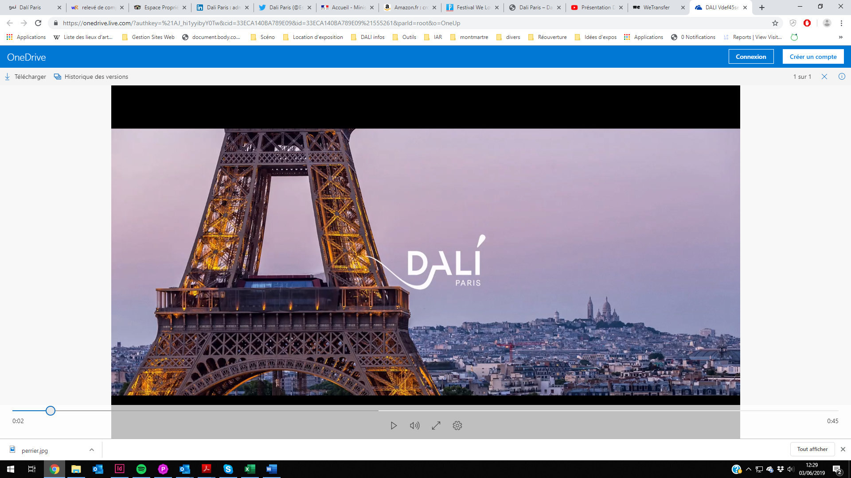

Please find a serie of logos and their related link

 [www.toutelaculture.com](http://www.toutelaculture.com)

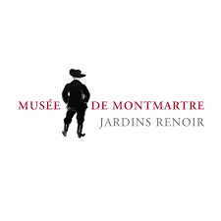<https://museedemontmartre.fr/>

<https://www.culturesecrets.com/>

<https://theatrelepic.com/>

FOOTER

In the footer, please use the full white Dali Paris logo

In the footer, Instagram is missing. Maybe it could be nicer to use the brand logo for facebook, tweeter, Instagram and trip advisor instead of the written names.

Blog is not visible in the French version